Raspberry Pi

**1.Introduction:**

**\* What is Raspberry Pi and what can you do with it?**

Raspberry pi is a series of small single-board computers developed in the united-kingdom by the Raspberry pi foundation in association with Broadcom. The raspberry pi project originally leaned towards the promotion of teaching basic computer science in schools and in developing countries.

Details: <https://en.wikipedia.org/wiki/Raspberry_Pi>

**2.Install and Setup Raspberry Pi:**

Flash the Raspberry Pi OS with SSH and wi-fi setup on micro-SD card-

1. First, install raspberry pi imager then run it. <https://www.raspberrypi.com/software/>

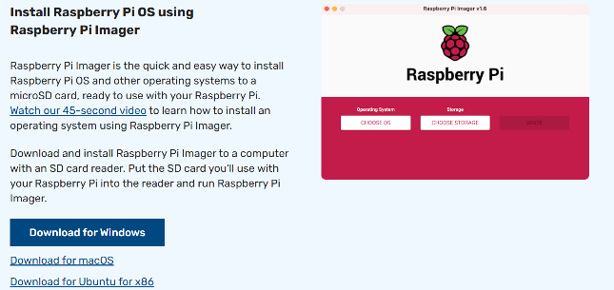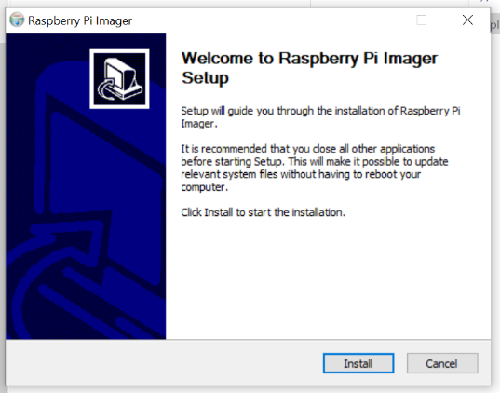

1. Second, Enter micro-SD card on laptop using card reader for flash. Open imager choose operating systems latest version (like, Raspberry Pi OS -32 bit) then select storage.

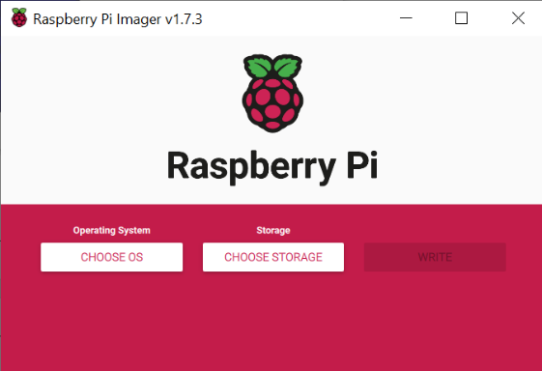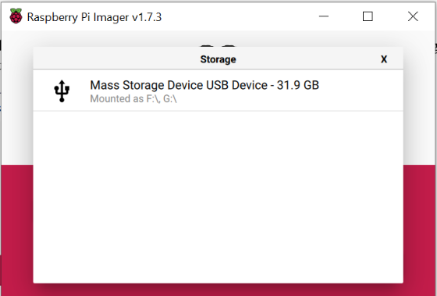

And, next go to setting and 1st step: to enable SSH and set a password (by default username is: pi)

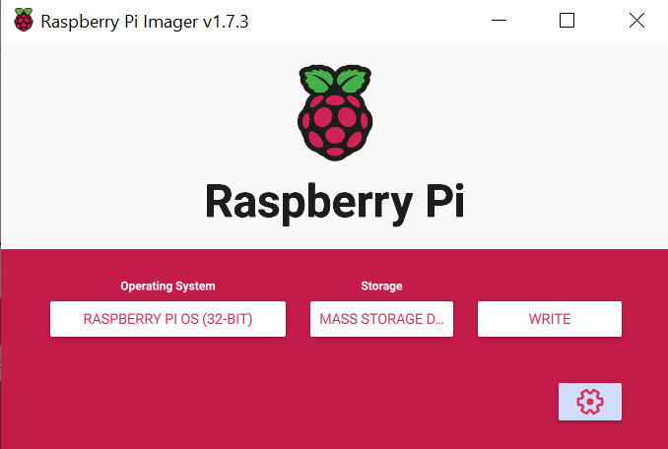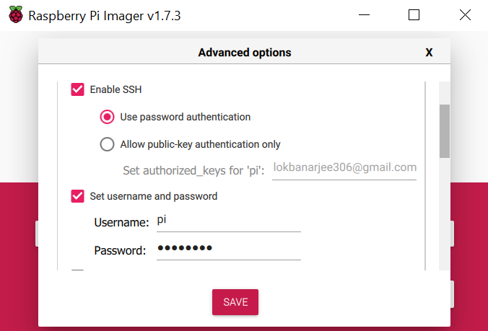

2nd step: configure wireless LAN (Make sure your laptop and configure network are same.) and then set-locale setting (for time zone) and “save it”

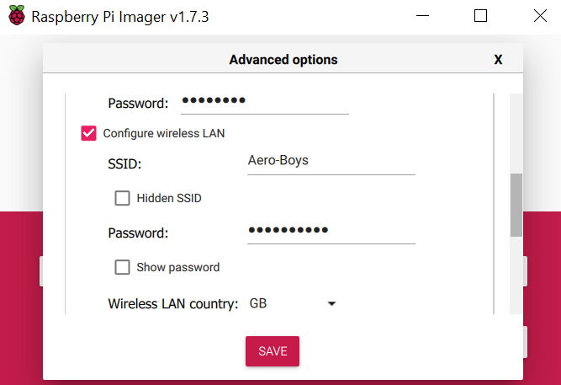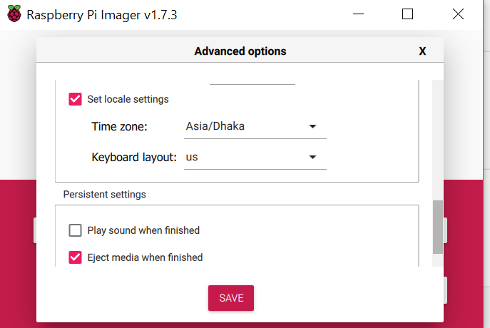

Finally, simply click on “**WRITE**”

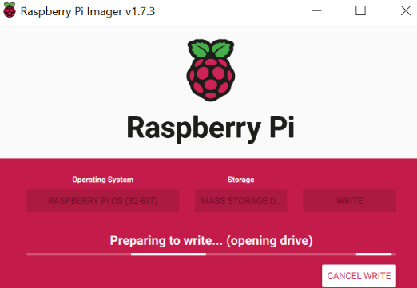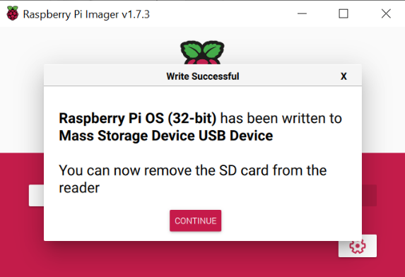

**3.Boot Raspberry Pi First Time:**

Micro-SD card which one is already flashed put it in raspberry pi board and connect to the power supply.

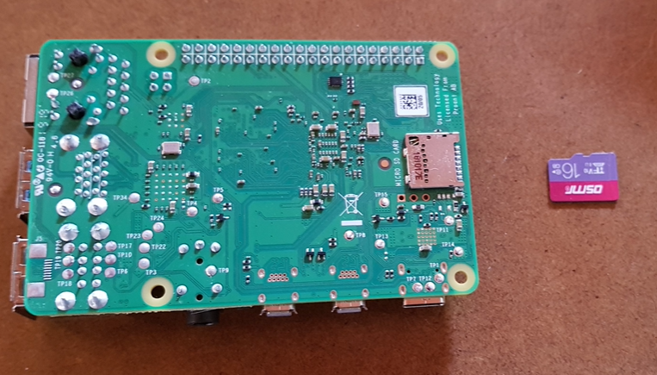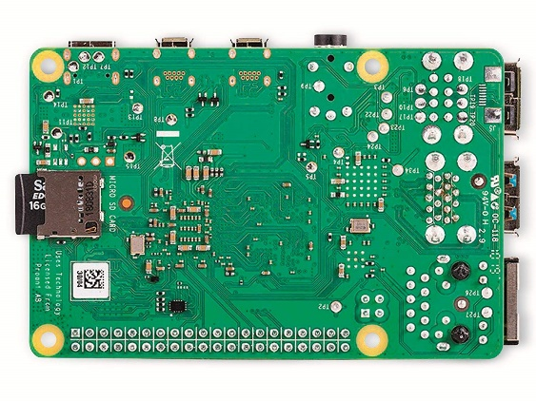

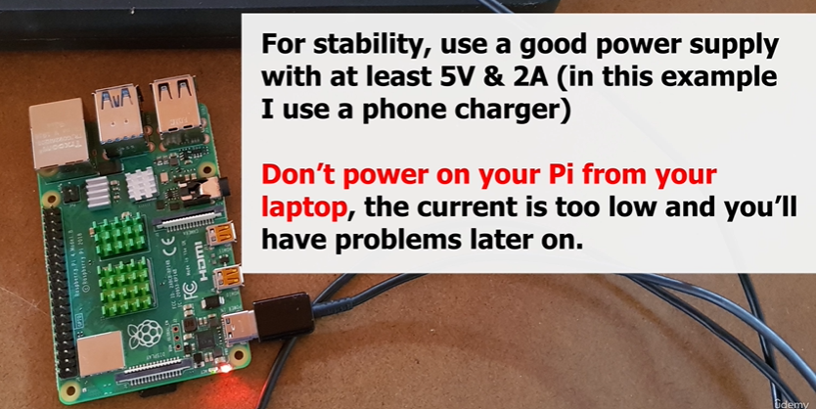

**#Find the Raspberry Pi’s IP address**

1st connect raspberry pi through ethernet port to wi-fi router to find Raspberry Pi address. Download: Angry IP Scanner - <https://angryip.org/download/#windows>

Aero-Boys: ***192.168.0.139***

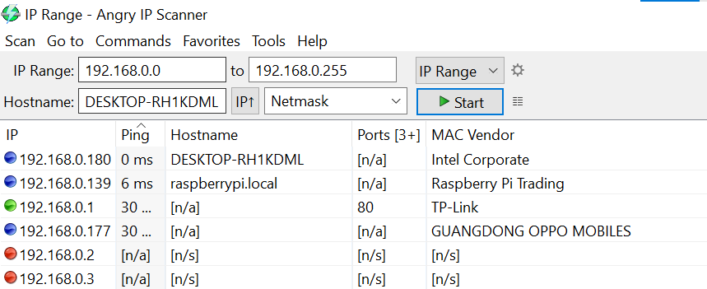

**#Connect to Pi using SSH**

Open CMD on windows search menu

Type- ssh [Enter]

ssh pi@ip_address_raspberryPi [Enter]

yes [Enter]

password [Enter]

Where, pi is a username of Raspberry pi.

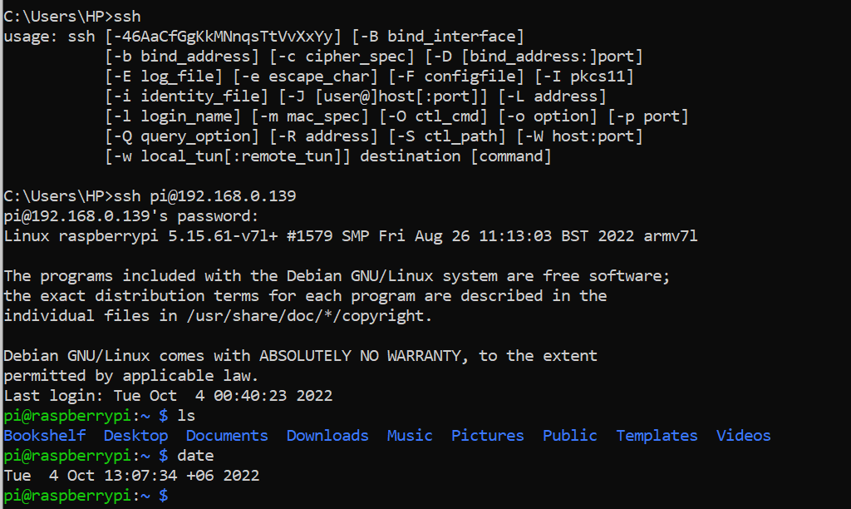

**3.Setup VNC to get a Remote access to Raspberry Pi OS Desktop**

1. Connect SSH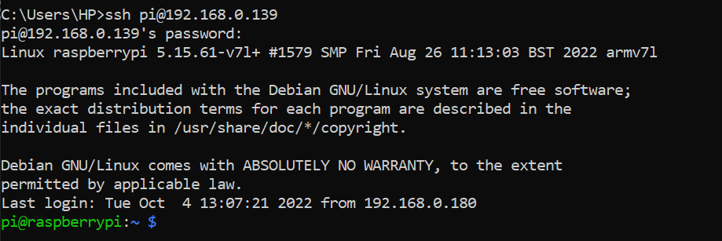
2. sudo raspi-config [Enter]
3. [Select] 3.Interface options [Enter]

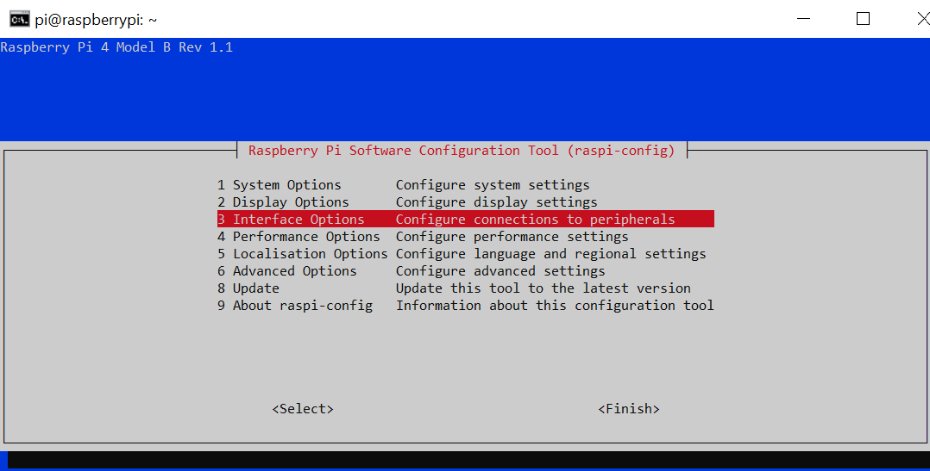

1. [Select] I3 VNC [Enter]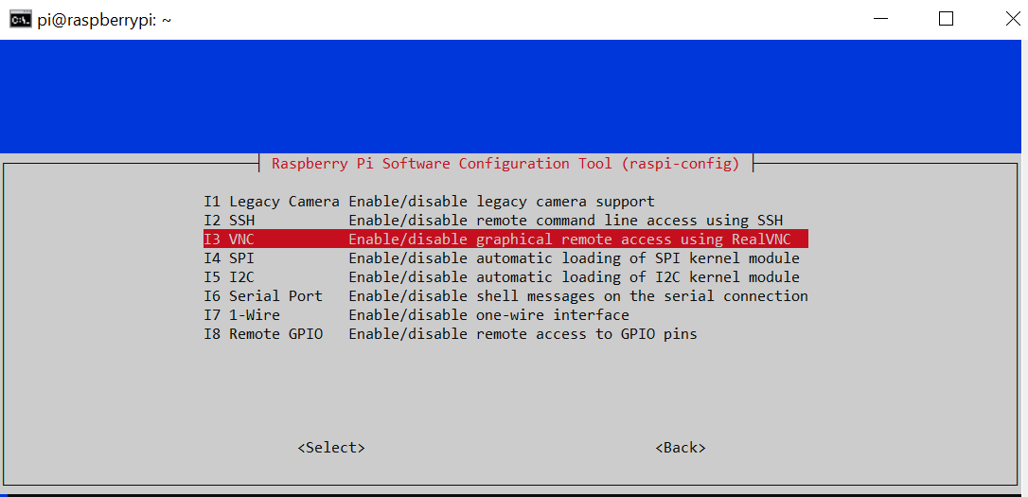
2. Yes [Enter – Enabled VNC Server]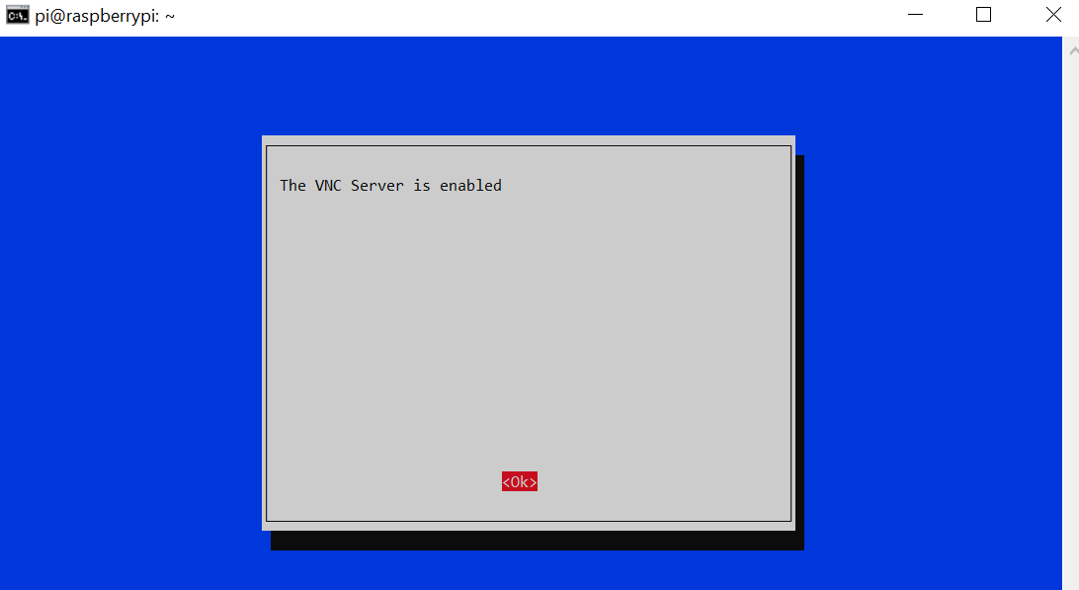
3. Finish [Enter] and Reboot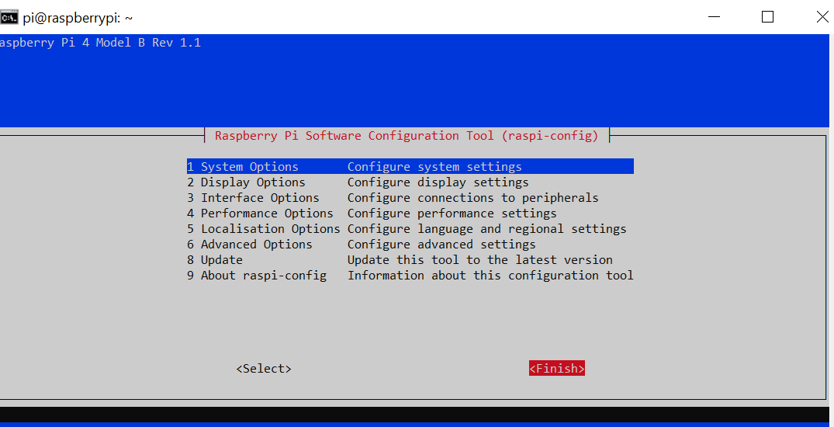

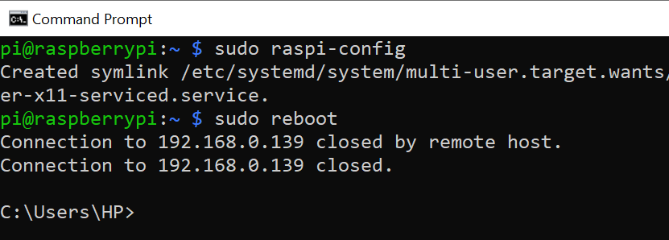

1. Again, Connect SSH, Type sudo raspi-config [Enter], go to; [Select] 1. System options [Enter] 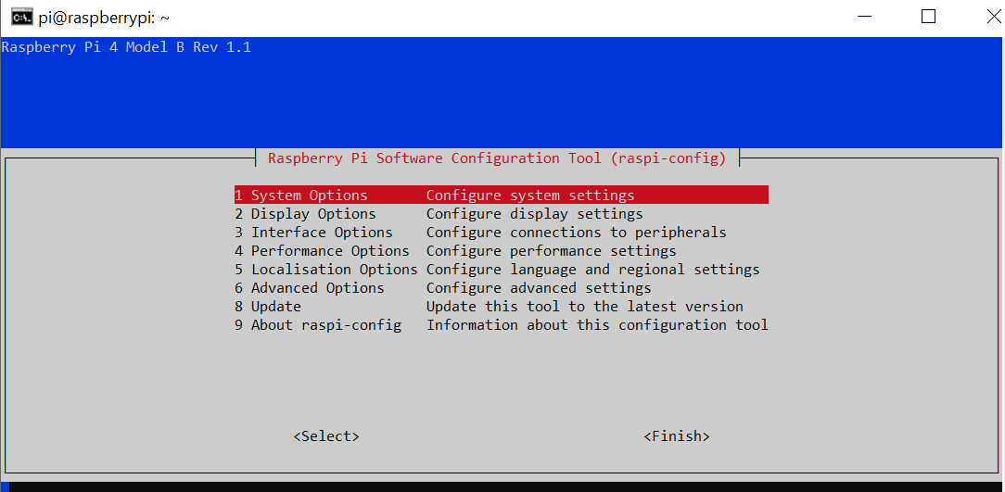
2. Then go to, [Select] S5 Boot/Auto login [Enter]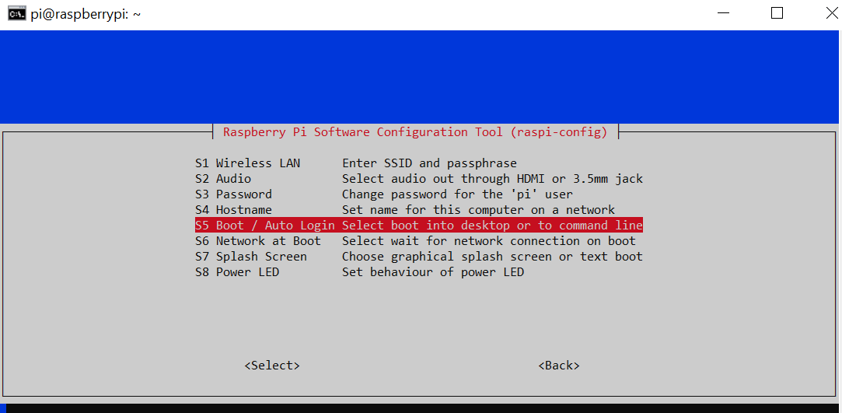
3. Again go to, [Select] B4 Desktop Auto login [Enter]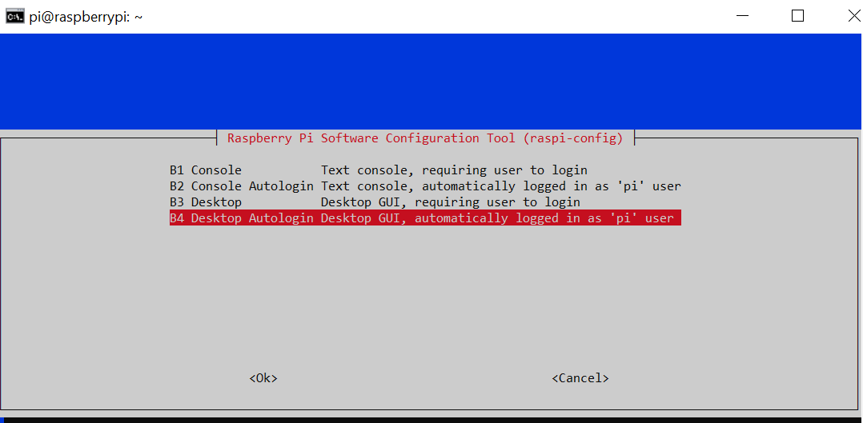
4. Finish and simply click “Yes” to reboot.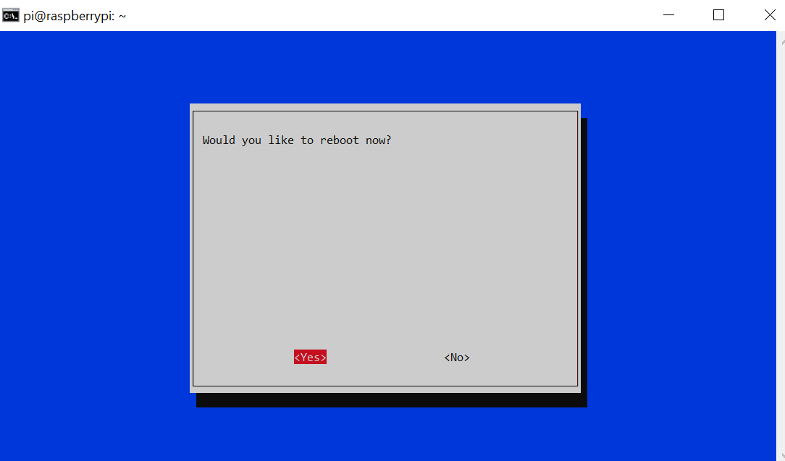
5. Finally, connect once more time SSH, and type sudo raspi-config [Enter] ; [Select] 2. Display options [Enter]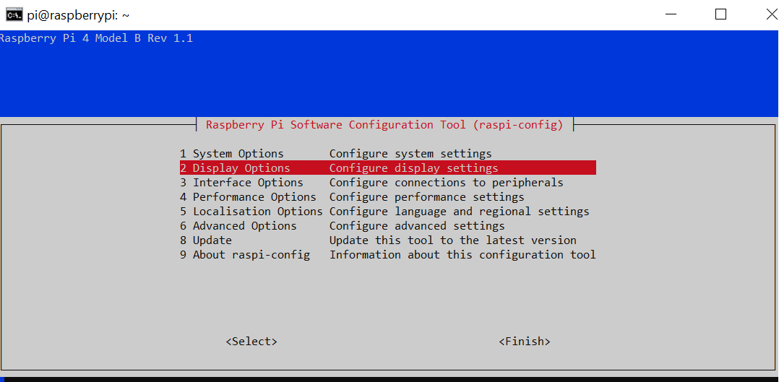
6. [Select] D5 VNC Resolution [Enter]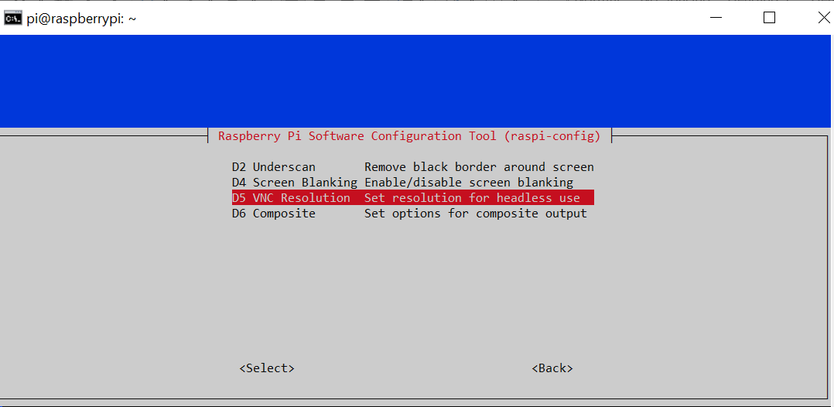
7. [Select] 1920x1080 [Enter]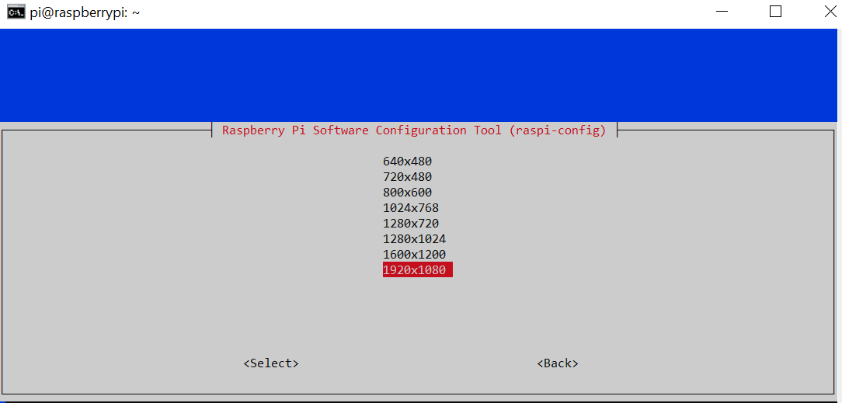
8. Click “Ok” Click “Finish” Click “Yes” to reboot.

**Download and Install VNC Viewer**

Search: “VNC viewer realvnc”

Link: <https://www.realvnc.com/en/connect/download/viewer/>

Open VNC viewer click on [***File – New connection***] Will open a form fill-up it. (VNC server will be IP address of raspberry Pi and Name = anything you Like) click “Ok”

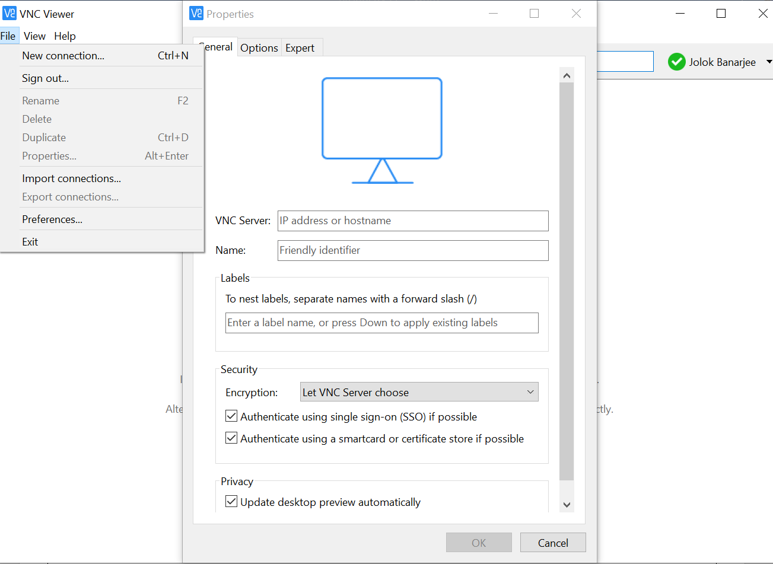

Double click on “Name” and provide Username, Password (same as Raspberry Pi) [Enter] “OK”.

